 Hkkjrh; izkS|ksfxdh LkaLFkku iVuk
Indian Institute of Technology Patna
Dept. of Electrical Engineering
IIT Patna, Campus, Bihta, Patna, Bihar – 801103 Experiment No.- 4

Study of Common-Emitter Amplifier

OBJECTIVES:

- To carry out an approximate DC and AC-analysis of the given CE amplifier.
- To determine the voltage gain, the “maximum undistorted peak-to-peak output voltage swing” (MUOVS) and the maximum input voltage for undistorted output.
- To study the effects of emitter bypass capacitor on voltage gain.

MATERIALS REQUIRED
- Breadboard : One
Transistor : One- NPN type 2N2222A.
Resistor : Five - 470 , 1K , 2.2 K , 22 K , 100K .
Capacitor : Three - 10 µ F, 10 µ F, 22 µ F

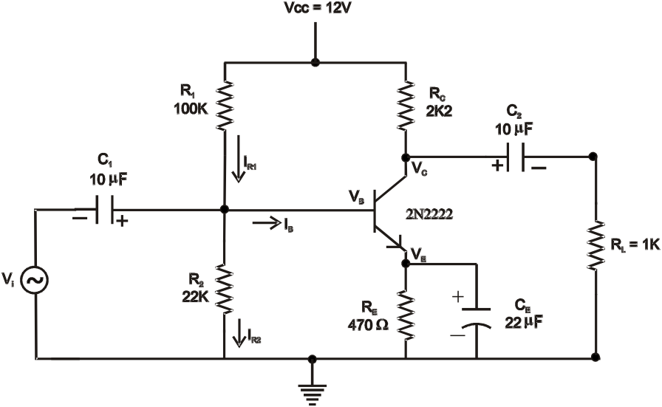

Fig. 1: Common-emitter amplifier

Important: You are expected to complete Part 1 at home and come to the Lab with a neat report showing all calculations. You will be allowed to continue with the rest of the experiment only after the instructor has checked the report.

Part-I. Pre-experiment preparation

Approximate DC and AC-analysis:
Carry out an approximate DC-analysis by using the values given in Fig. 1 and by making use of the following assumptions:

(a) I_{R1}, I_{R2} >> I B, so that I_{R1} I_{R2}
(b) VBE 0.65 V
Under these assumptions, you should be able to estimate the
(C) DC quantities (quiescent values) V_{B}, V_{E} , V_{C} , I_{C} ( I_{E} )

-1

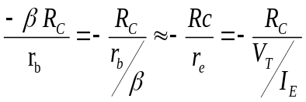
Voltage Gain 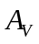=

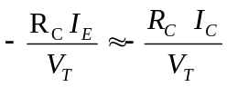= (4.1)
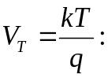
Where = the thermal voltage; k= Boltzmann’s constant = 1.38 x 10⁻²³ J/K

q = 1.6 x 10⁻¹⁹ Coulomb, T is temperature in Kelvin.
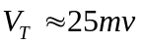
Take (at a room temp of 20º C)
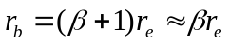
In (4.1), we have used the approximation

Note: The approximation does not require the knowledge of

MUOVS = 2 * Min {V_{CC} –V_{C}, V_{C} –V_{E} }

Q: (connecting an electrolytic capacitor) How do you decide that the + ve terminal of C₁ should be connected to the R1–R2 node and the –ve terminal to the source Vi ? Likewise, for C₂ and C_{E}.
2.1 Experimental determination of the quiescent voltages and currents:
(a) Before assembling the circuit, measure the actual values of the resistors by means of a Digital Multi Meter (DMM). [Remember you are using resistors with 10% tolerance]. The actual values are to be used in determining the currents.
(b) Now assemble the circuit, apply V_{CC} and note the following:
- measure V_{BE} using DMM; it should be around 0.6 ~ 0.7 V indicating that B_{E}-junction is forward biased.
- Measure V_{C} and check if V_{E} < V_{C} < V_{CC}. A value of V_{C} midway between V_{E} and V_{CC}
is preferable (Q1: Why is such a value preferable?).
If your measurements agree, you are along the right path.
(c) Now measure V_{B}, V_{E}, V_{C} and V_{CC}; then using the measured resistance values, determine I_{B}, I_{E}, I_{C} and
hence ( =I_{C} / I_{B}).
(d) Compare the experimentally determined values of the currents and voltages with those you obtained through
approximate analysis.
(e) Compare the experimentally determined value of with the approximate value stated in the manual or given by the Lab Instructor.
(f) Compute AV (equation 4.1) using the experimentally determined values of R_{C} and I_{C}. Use V_{T} = 25mV.
2.2 Voltage gain without load resistance RL:
Disconnect C2.
Adjust FG to get approximately 20mV peak-to-peak sinusoid at 1 kHz (display in Ch- I). Apply this voltage at amplifier input (V_{i}).
Display collector voltage in Ch-2 of DSO (use DC-coupling). Note the 180º phase difference between the input and the output. Adjust V_{i} amplitude to get a convenient value for peak-to-peak collector voltage V_{C}, PP ( say 3.6 V). Note the corresponding V_{i}, PP (mV). Experimentally obtained voltage gain is therefore:
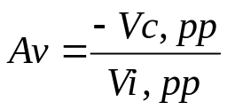

-2-

Compare this value with the computed values obtained in step 2.1(f). Also compare this value with the value estimated in your pre-reading assignment.
3. Maximum undistorted output voltage swing (MUOVS)
Increase V_{i} slowly till you observe a slight flattening of V_{C} waveform at its peaks (either positive peaks or negative peaks). The peak-to-peak value of the output signal (just at the onset of distortion/clipping) is the MUOVS. Measure the corresponding V_{i}, PP, the peak- to-peak input voltage.
This information is useful in an amplifier: it tells the user that the input should not exceed this value for faithful amplification of the signal, else distortions sets in.
Now increase V_{i} beyond this point and observe the output waveform. The sinusoid gets increasingly flattened and becomes more like a square wave. (Overdriving an amplifier leads to heavy distortion)
[ !! Square-wave from a sine-wave]

4. Voltage-gain with load resistance RL:

The output of an amplifier normally drives a load resistance R_{L} which may represent an actual load like an ear-phone or a loudspeaker, or the input impedance of another state of amplifier.
Connect R_{L} (see circuit) to the collector through the coupling capacitor C₂ (C₂ blocks the DC voltage at the collector and allows only the AC i.e. the signal component to pass through).
Measure A_{V} with R_{L} connected. (You would observe a reduced Av since R_{C}, eff = Rc||R_{L}).

5. Effect of CE on Av:
Get back to the conditions in Part 2.2 i.e. Vi at 1 KHz, its amplitude adjusted to get V_{C}, PP 3.6V approx. Now, remove C_{E} (with ckt. powered) and note the drastic reduction in VC, PP. You have to change to appropriate V/div in your DSO. Determine the gain of the C_{E} amplifier with unbypassed R_{E}
Compare your observation with the theoretical value
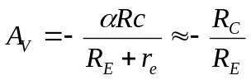
(4.2)

- Display and sketch V_{i} and VE waveforms. Note the amplitudes and the phase-relationship between them.
- Display and sketch V_{E} and V_{C}. Note the amplitudes and the phase relationship. Please note that you are in DC coupling mode of the DSO. Please ensure that when you pressed the ground options in CH1 and CH2, both the horizontal traces (of CH1 and CH2) are coinciding. Also ensure that the V/div of CH1 is equal to V/div of CH2.
- 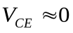Increase V_{i} gradually and observe how V_{E} and V_{C} change. Continue to increase V_{i} till you observe the +ve peak of V_{E} (almost) touching the negative peak of V_{C}. When this occurs, we say that the BJT has gone into saturation ( ).

Q2: What do you observe if Vi is increased beyond this point?

-3-

